第一课 问候 Lesson 1 Greetings
I. Introduction
Standard Chinese (普通话pǔ tōng huà / 国语guó yǔ / 汉语hàn yǔ) is a standardized form of spoken Chinese based on the Beijing dialect of Mandarin. It is the official language of China and Taiwan, as well as one of four official languages of Singapore. It is one of the six official languages of the United Nations.

Spoken Chinese is separated into five main dialectical groups - Mandarin, Yue (i.e., Cantonese), Min, Wu and Hakka, covering more than 200 individual dialects. Mandarin is considered a native language by about two-thirds of China’s inhabitants, making it the most dominant spoken Chinese dialect, while Cantonese lays claim to approximately 55 million speakers in China alone.

II. Tone Language
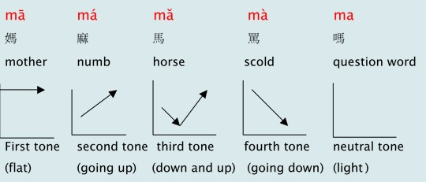
III. Pinyin Chart
- Video [3:16]: 聲母韻母歌
- Video [5:41]: The Chinese Phonetic Song 汉语拼音歌

IV. How to write Chinese characters?
Two basic rules: 1) Top before bottom and 2) Left before right
V. Vocabulary Table
中文 (Chinese) | 拼音(Pinyin) | 英文 (English)
大家 | dà jiā | Big + Family => Everyone
好 | hǎo | Good
我 | wǒ | I
叫 | jiào | Be called
我的 | wǒ de | My (pronoun)
名字 | mín gzì | Name
是 | shì | Be (is, am, are) verb
很 | hěn | Very much
高興 | gāo xìng | Hyper+Happy => Pleased, Happy
見到 | jiàn dào | Meet (emphasis on“met”)
您 | nín | You (with respect)
你 | nǐ | You (for male or everyone)
妳 | nǐ | You (for female)
什么 | shén me | What?
**Homework: Write at least twice Chinese characters and Pinyin above.

VI. 对话 Dialogue
大家好！
Dà jiā hǎo!
Hello everyone!

我叫刘欣萍。(我的名字是刘欣萍。)
Wǒ jiào liú xīn píng. (Wǒ de mín gzì shì liú xīn píng.)
My name is Liu Shin-Ping. (My name is Shin-Ping Liu)

很高興見到（你， 妳）您。
Hěn gāo xìng jiàn dào (nǐ, nǐ) nín.
Nice to meet you.

VII. Videos
- Video [3:09]: 10 Fun Facts about China for Children Video
- Video [14:33]: Chinese - The Sinitic Languages
- Video [8:58]: Basics of Chinese Grammar Explained in 10 Minutes
- Video [6:10]: Learn to read Chinese ... with ease! | ShaoLan
- Video [3:21]: 為什麼我決定學習中文? ! (WHY I DECIDED TO LEARN CHINESE?) [中文視頻博客] 外國女孩說中文~!

