第六课 两只老虎 Lesson 6 Two Tigers
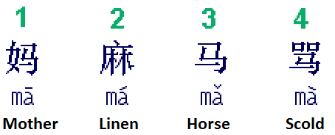 |  | How to write Chinese characters?  Two basic rules:  1) Top before bottom  2) Left before right
中文 (Chinese) | 拼音 (Pinyin) |  | 英文 (English)
一 二 三 四 五 六 七 八 九 十 | yī' èr sān sì wǔ liù qī bā jiǔ shí |  | One two three four five six seven eight nine ten
两只 | liǎng zhī |  | Two; two units
老虎 | lǎo hǔ |  | Tiger
跑得快 | pǎo dé kuài |  | Run fast
没有 | méi yǒu |  | Do not have
耳朵 | ěr duǒ |  | Ear
尾巴 | wěi bā |  | tail
真奇怪 | zhēn qí guài |  | Really weird
Homework: Write at least twice Chinese characters above.

两只老虎

两只老虎 两只老虎
跑得快 跑得快
一只没有耳朵
一只没有尾巴
真奇怪 真奇怪

