第七课 自我介绍 Lesson 7 Self-Introduction
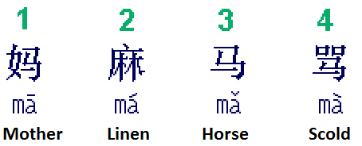 |  | How to write Chinese characters?  1) Top before bottom  2) Left before right
中文 (Chinese) | 拼音 (Pinyin) |  | 英文 (English)
一 二 三 四 五 六 七 八 九 十 | yī' èr sān sì wǔ liù qī bā jiǔ shí |  | One two three four five six seven eight nine ten
自我介绍 | zì wǒ jiè shào |  | Myself + Introducing => Self-introduction
老师 | lǎo shī |  | Teacher
大家 | dà jiā |  | Everybody
好 | hǎo |  | Good
我叫 | wǒ jiào |  | I’m called
今年 | jīn nián |  | This Year
十四岁 | shí sì suì |  | 14 years old
来自 | lái zì |  | Come from
美国 | měi guó |  | America
我是个… | wǒ shì gè |  | I’m a(n)
学生 | xué shēng |  | Student
喜欢 | xǐ huān |  | Like
打游戏 | dǎ yóu xì |  | Play video games
拉小提琴 | lā xiǎo tí qín |  | Play violin
睡觉 | shuì jiào |  | Sleep
吃饭 | chī fàn |  | Eat rice
和 | hé |  | And
也 | yě |  | Too; also
学中文 | xué zhōng wén |  | Learn Chinese
谢谢大家! | xiè xiè dà jiā |  | Thank you all!

自我介绍 (Self-Introduction):

老师好!
大家好!
我叫唐祥。
我今年十四岁。
我来自美国。
我是个学生。
我喜欢打游戏，拉小提琴，睡觉，和吃饭。
我也喜欢学中文。
谢谢大家！

