茉莉花 Jasmine Follower
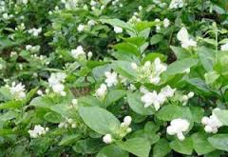 | 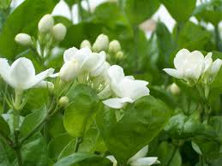 | 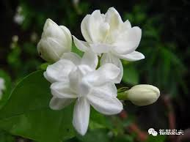

中文 (Chinese) | 拼音 (Pinyin) | 英文 (English)
茉莉花 | mò lì huā | Jasmine flower
一朵 | yì duǒ | A piece of (Flower)
美丽的 | měi lì de | Beautiful
芬芳 | fēn fāng | Fragrant; aromatic
满 | mǎn | Full, complete
枝桠 | zhī yā | Branches
又 | yòu | Also
香 | xiāng | Good-smelling; fragrant
白 | bái | White
夸 | kuā | To praise
让 | ràng | Let
将 | jiāng | Be going to; will\shall
摘下 | zhāi xià | pluck down; pick off
送給 | sòng gěi | Give away; give
別人 | bié rén | Other people
家 | jiā | Home; household
Chinese Folk Song Lyrics:

茉莉花 Jasmine Flower

好一朵美丽的茉莉花
Hǎo yì duǒ měi lì de mò lì huā
What a beautiful jasmine flower!

好一朵美丽的茉莉花
Hǎo yì duǒ měi lì de mò lì huā
What a beautiful jasmine flower!

芬芳美丽满枝桠
Fēn fāng měi lì mǎn zhī yā
Fragrant and beautiful smell fulfills branches

又香又白人人夸
Yòu xiāng yòu bái rén rén kuā
Also good-smelling also white everyone praises

让我来将你摘下
Ràng wǒ lái jiāng nǐ zhāi xià
Let me come to pluck you down

送给别人家
Sòng gěi bié rén jiā
Give to other people’s household

茉莉花呀茉莉花
Mò lì huā ya mò lì huā
Jasmine flower oh jasmine flower

- Video [2:12]: Jasmine Flower Song
- Video [4:15]: 歌曲《茉莉花》宋祖英 席琳.迪翁 2013央视蛇年春晚

