第一课 问候 Lesson 1 Greetings

I. Introduction
Standard Chinese (普通话pǔ tōng huà / 国语guó yǔ / 汉语hàn yǔ) is a standardized form of spoken Chinese based on the Beijing dialect of Mandarin. It is the official language of China and Taiwan, as well as one of four official languages of Singapore. It is one of the six official languages of the United Nations. Video [10:18]: Introduction to China in 10 minutes
II. Tone Language
III. Pinyin Chart
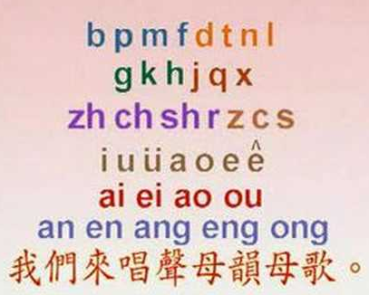 | - Video [3:16]: 聲母韻母歌
IV. How to write Chinese characters?
Two basic rules: 1) Top before bottom; 2) Left before right

V. Vocabulary Table
中文 (Chinese) | 拼音 (Pinyin) | 英文 (English)
你 | nǐ | You
好 | hǎo | Good
您 | nín | You (with respect)
你们 | nǐ men | You guys
爷爷 | Yé yé | Grandpa
早上 | zǎo shàng | Morning
小明 | xiǎo míng | Boy’s name (Little Bright)
**Homework: Write at least twice Chinese characters and Pinyin above.

VI. 对话 Dialogue
小明: 爷爷, 您好!
Xiǎo míng: Yé yé, nín hǎo!
Xiao Ming: Hello Grandpa.

爷爷: 小明, 你好!
Yé yé: xiǎo míng nǐ hǎo
Grandpa: Hello Xiao Ming.

小明: 爷爷, 早上好。
Xiǎo míng: Yé yé, nín hǎo!
Xiao Ming: Good morning, grandpa.

爷爷: 小明, 早上好。
Yé yé: xiǎo míng nǐ hǎo
Grandpa: Good morning, Xiao Ming.

VII. 成长汉语Growing up with Chinese

Hostess: Charlotte MacInnis (Ai Hua), A white-faced Chinese
Charlotte MacInnis, an American girl who has embraced and adopted Chinese culture and tradition as her own. Meanwhile, she is beloved by the Chinese people, and they have accepted her as a Chinese, not a foreigner. She has graced the stages and TV screens of China since the young age of 10. "Ai Hua", meaning Love China, is her Chinese name. And the name proves very appropriate, for not only does she love the Chinese, but the Chinese love her as well.

III. Videos
- Video [14:55]: Growing up with Chinese Lesson 1 Greetings - CCTV
- Video [14:55]: Growing up with Chinese Lesson 1 Greetings - Youtube
- Video [5:38]: 6 Reasons Why You Should Learn Mandarin!

茉莉花 Jasmine Follower

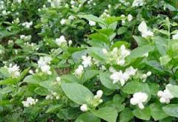 | 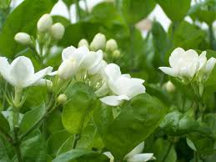 | 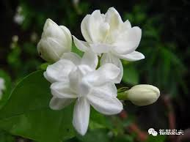

中文 (Chinese) | 拼音 (Pinyin) | 英文 (English)
茉莉花 | mò lì huā | Jasmine flower
一朵 | yì duǒ | A piece of (Flower)
美丽的 | měi lì de | Beautiful
芬芳 | fēn fāng | Fragrant; aromatic
满 | mǎn | Full, complete
枝桠 | zhī yā | Branches
又 | yòu | Also
香 | xiāng | Good-smelling; fragrant
白 | bái | White
夸 | kuā | To praise
让 | ràng | Let
将 | jiāng | Be going to; will\shall
摘下 | zhāi xià | pluck down; pick off
送給 | sòng gěi | Give away; give
別人 | bié rén | Other people
家 | jiā | Home; household

Chinese Folk Song Lyrics:
茉莉花 Jasmine Flower

好一朵美丽的茉莉花
Hǎo yì duǒ měi lì de mò lì huā
What a beautiful jasmine flower!

好一朵美丽的茉莉花
Hǎo yì duǒ měi lì de mò lì huā
What a beautiful jasmine flower!

芬芳美丽满枝桠
Fēn fāng měi lì mǎn zhī yā
Fragrant and beautiful smell fulfills branches

又香又白人人夸
Yòu xiāng yòu bái rén rén kuā
Also good-smelling also white everyone praises

让我来将你摘下
Ràng wǒ lái jiāng nǐ zhāi xià
Let me come to pluck you down

送给别人家
Sòng gěi bié rén jiā
Give to other people’s household

茉莉花呀茉莉花
Mò lì huā ya mò lì huā
Jasmine flower oh jasmine flower

- Video [2:12]: Jasmine Flower Song
- Video [4:15]: 歌曲《茉莉花》宋祖英 席琳.迪翁 2013央视蛇年春晚

