第二课中国新年Lesson 2 Chinese New Year
- Pinyin Chart
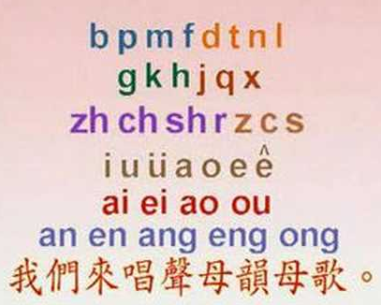 | - Video [3:16]: 聲母韻母歌
II. How to write Chinese characters? Two basic rules: 1) Top before bottom; 2) Left before right

III. Vocabulary Table
中文 (Chinese) | 拼音 (Pinyin) | 英文 (English)
中国 | zhōn guó | China; Chinese
新年 | xīn nián | New Year
快乐 | kuài lè | Happy
春节 | chūn jié | Spring festival
恭喜 | gōng xǐ | Congratulations!
发财 | fā cái | Make more money
红包 | hóng bāo | Red bag with cash
拿 | ná | Take
来 | lái | Come
这 | zhè | This
是 | shì | Be (is/am/are)
的 | de | Of; Possessive particle
年 | nián | Year
今年 | jīn nián | This year
什么 | shén me | What?
鸡 | jī | Fowl, chicken, Rooster
祝 | zhù | Wish
行大运 | xíng dà yùn | Have a big good luck!
**Homework: Write at least twice Chinese characters and Pinyin above.

IV. 对话 (Dialogue)
小明: 爷爷, 恭喜发财! 红包拿来!
Xiǎo míng: Yé yé, gōng xǐ fā cái! hóng bāo ná lái
Xiao Ming: Grandpa. Wish you earn more money! Please give me a red bag.

爷爷: 小明, 新年快乐! 这是你的红包。
Yé yé: Xiǎo míng, xīn nián kuài lè! zhè shì nǐ de hóng bāo.
Grandpa: Xiao Ming, Happy New Year! This is your red bag.

小明: 今年是什么年?
Xiǎo míng: Jīn nián shì shén me nián?
Xiao Ming: What is this year?

爷爷: 今年是鸡年.
Yé yé: Jīn nián shì jī nián.
Grandpa: This year is a rooster year.

小明: 爷爷, 祝您鸡年行大运!
Xiǎo míng: Yé yé, zhù nín jī nián xíng dà yùn
Xiao Ming: Wish you have a happy rooster year!

III. Videos
- Video [4:56]: Chinese New Year - Chinese culture about how Chinese people prepare and celebrate Spring Festival
- Video [2:41]: Bet You Didn't Know: Chinese New Year | History
- Video [11:34]: Chinese New Year family traditions

