第三课 你叫什么名字？ Lesson 3 What is your name?
I. Pinyin Chart
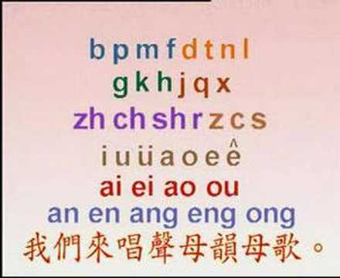 | - Video [3:16]: 聲母韻母歌
III. How to write Chinese characters?
Two basic rules: 1) Top before bottom; 2) Left before right

IV. Vocabulary Table
中文 (Chinese) | 拼音 (Pinyin) | 英文 (English)
我 | wǒ | I
他 \ 她 | tā \ tā | He \ She
们 | men | A group of people
名字 | míng zì | Name
我的名字是 ____ | wǒ de míng zì shì | My name is _______
叫 | jiào | Be called
什么 | shén me | What?
你叫什么名字？ | nǐ jiào shén me míng zì? | What is your name?
吗 | ma | A question marker
你好吗？ | nǐ hǎo ma? | How are you?
很 | hěn | Very
我很好 | wǒ hěn hǎo | I am fine.
呢 | ne | Question particle
你呢? | nǐ ne | How about you?
也 | yě | Also, too
谢谢 | Xiè xiè | Thanks!
见到 | jiàn dào | Have seen
高兴 | gāo xìng | Happy
见到你很高兴 | jiàn dào nǐ hěn gāoxìng | Nice to meet you!
麦克 | mài kè | Wheat+ Gram => Mike
**Homework: Write at least twice Chinese characters and Pinyin above.

V. 对话 (Dialogue)
小明: 早上好! 你好吗？
zǎo shang hǎo! nǐ hǎo ma?
Good morning! How are you?

麦克: 我很好, 谢谢! 你呢?
wǒ hěn hǎo, xiè xiè! nǐ ne?
I am fine, thanks! How about you?

小明: 我也很好, 谢谢! 你叫什么名字？
wǒ yě hěn hǎo, xiè xiè! nǐ jiào shén me míng zì?
I'm fine, too. Thank you! What's your name?

麦克: 我叫麦克. 你呢?
wǒ jiào mài kè. nǐ ne?
My name is Mike. How about you?

小明: 我叫小明.
wǒ jiào xiǎo míng.
I’m called Xiao ming.

麦克: 见到你很高兴.
jiàn dào nǐ hěn gāo xìng.
Nice to meet you.

小明: 见到你我也很高兴.
Jiàn dào nǐ wǒ yě hěn gāoxìng
Nice to meet you, too.

Class ID | Last Name | First Name | Chinese Name | Meaning
0001 | Decker | Alan | 邓伦  dèng lún | Surname + Ethics
0002 | Forte | Aurora | 方若  fāng ruò | Square + Seem
0003 | Kriske | Jennifer | 柯妮  kē nī | Stem + Girl
0004 | Kriske | Michelle | 柯米  kē mǐ | Stem + Rice
0005 | Pedersen | Theodore | 贝德  bèi dé | Shell+ Virtue
0006 | Praske | Laura | 白兰  bái lán | White + Orchid
0007 | Spaeth | Susan | 苏珊  sū shān | Awake + Coral
0008 | Swanson | Valerie | 法丽  fǎ lì | Large Number + Law + Beautiful
0009 | Toftey | Angela | 凃安  tu ān | Coated + Peace
0010 | Tucker | Sean | 唐祥  táng xiáng | Dynasty + Auspicious

- Video [14:48]: Growing up with Chinese Lesson 3 Name

