第四 课 起床 Lesson 4 Getting out of bed

I. Pinyin Chart
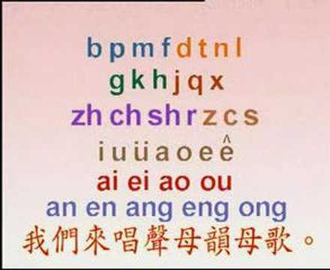 | - Video [3:16]: 聲母韻母歌
III. How to write Chinese characters?
Two basic rules: 1) Top before bottom; 2) Left before right

IV. Vocabulary Table

中文 (Chinese) | 拼音 (Pinyin) | 英文 (English)
一 二 三 四 五 六 七 八 九 十 | yī èr sān sì wǔ liù qī  bā jiǔ shí | one two three four five six seven eight nine ten
起床 | qǐ chuáng | Rise + Bed => Get Up
啦 | la | Final particle
怎么 | zěn me | How come?
还 | hái | Still
睡 | shuì | Sleep
该 | gāi | Should; ought to
了 | Le | Past tense marker
吧 | ba | Final particle
嘘 | xū | Hush
别吵 | bié chǎo | Do not quarrel
今天 | jīn tiān | Current + Day => Today
周末 | zhōu mò | Week + End => Weekend
多睡 | duō shuì | More Sleep
一会儿 | yī huǐ er | One + Opportunity + Suffix => For a while
看 | kàn | See, look
都 | dōu | All
快 | kuài | Soon
点 | diǎn | Point
有 | yǒu | Have, exist
时差 | shí chā | Time + Difference => Jet lag
先 | xiān | First
吃 | chī | Eat
早饭 | zǎo fàn | Morning + Cooked rice => Breakfast
元宵节 | yuán xiāo jié | First + Night + Festival => Lantern festival
**Homework: Write at least twice Chinese characters and Pinyin above.

V. 对话 (Dialogue)
妈妈：小明，起床啦？
Māmā: xiǎo míng, qǐ chuáng la?
Mom: Xiao Ming, you're up？

小明：妈，麦克怎么还睡呢！该起床了吧？
Xiǎomíng: mā, mài kè zěn me hái shuì ne! gāi qǐ chuáng le ba?
Xiao Ming: Mom，how come Mike is still sleeping！He should be up by now？

妈妈：嘘，你别吵，今天是周末，让他多睡一会儿吧。
Māmā: xū, nǐ bié chǎo, jīn tiān shì zhōu mò, ràng tā duō shuì yī huǐ er ba.
Mom: Shhh，don't be so loud，today's the weekend，let him sleep in a little.

小明：啊？还睡！您看，都快十点了。
Xiǎomíng: a? hái shuì! nín kàn, dōu kuài shí diǎn le.
Xiao Ming：What？Sleep more！Look，it's nearly ten o'clock.

妈妈：他还有时差呢，你先吃早饭吧。
Māmā: tā hái yǒu shí chā ne, nǐ xiān chī zǎo fàn ba.
Mom: He's got jet lag，you have breakfast first.

小明：好吧。
Xiǎomíng: Hǎo ba.
Xiao Ming：Alright.

小明：妈，我下楼打会儿球。
Xiǎomíng: Mā, wǒ xià lóu dǎ huì er qiú.
Xiao Ming：Mom, I'm going downstairs to play ball.

妈妈：你去吧，早点儿回来。
Māmā: Nǐ qù ba, zǎo diǎn er huí lái.
Mom: Go ahead，don't be too long.

VI. Videos:
- Video [14:56]: Growing up with Chinese Lesson 11 Getting out of bed
- Video [5:33]: 《中国文化欣赏》元宵节 Exploring Chinese Culture - Lantern Festival
- Video [3:32]: The Chinese Lantern Festival

VII. Practice
妈妈：小明，起床啦？
小明：妈，麦克怎么还睡呢！该起床了吧？
妈妈：嘘，你别吵，今天是周末，让他多睡一会儿吧。
小明：啊？！还睡！您看，都快十点了。
妈妈：他还有时差呢，你先吃早饭吧。
小明：好吧。
小明：妈，我下楼打会儿球。
妈妈：你去吧，早点儿回来。

