第一课 问候 Lesson 1 Greetings
I. Introduction
Standard Chinese (普通话pǔ tōng huà / 国语guó yǔ / 汉语hàn yǔ) is a standardized form of spoken Chinese based on the Beijing dialect of Mandarin. It is the official language of China and Taiwan, as well as one of four official languages of Singapore. It is one of the six official languages of the United Nations.
II. Tone Language
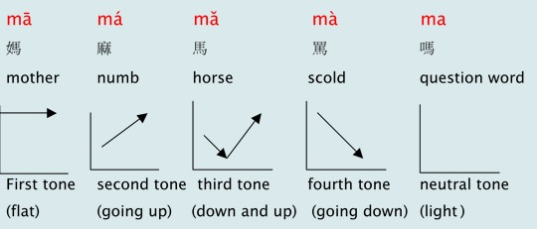

III. Pinyin Chart
- Video [3:16]: 聲母韻母歌

IV. How to write Chinese characters?
Two basic rules: 1) Top before bottom; 2) Left before right

V. Vocabulary Table
中文 (Chinese) | 拼音 (Pinyin) | 英文 (English)
早上 | zǎo shàng | Early + Upper => Morning
好 | hǎo | Good
您 | nín | You (with respect)
你 | nǐ | You
叫 | jiào | Be called
什么 | shén me | What?
名字 | míng zì | Name
我 | wǒ | I
姓 | xìng | Surname
呢 | ne | Question particle
**Homework: Write at least twice Chinese characters and Pinyin above.

VI. 对话 Dialogue
A: 早上好!
Zǎo shàng hǎo!
Good morning!

B: 您好!
Nín hǎo!
How are you?

A: 你叫什么名字?
Nǐ jiào shén me míng zì?
What is your name?

B: 我姓刘, 叫欣萍. 您呢?
Wǒ xìng liú, jiào xīn píng. Nín ne?
My surname is Liu, first name is Shin-Ping. How about you?

A: 我叫贝德.
Wǒ jiào bèi dé.
My name is Bei De.

VII. Videos
- Video [5:14]: History of Chinese characters
- Video [3:36]: 10 Fun Facts About China
- Video [5:38]: 6 Reasons Why You Should Learn Mandarin!

