第三课 十二生肖 Lesson 3 Chinese Zodiac Signs

I. Pinyin Chart
b p m f d t n l  g k h j q x  zh ch sh r z c s  i u ϋ a o e ê  ai ei ao ou  an en ang eng ong  我们来唱声母韵母歌 。 | - Video [3:16]: 聲母韻母歌  - Video [5:41]: The Chinese Phonetic Song 汉语拼音歌

II. Chinese Zodiac 十二生肖
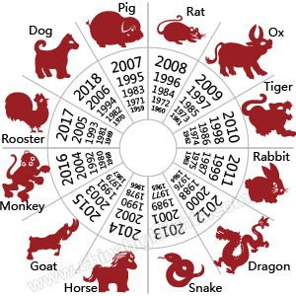

III. Vocabulary Table
中文 (Chinese) | 拼音 (Pinyin) | 英文 (English)
零 一 二 三 四 五  六 七 八 九 十 百  千 万 | líng yī èr sān sì wǔ liù qī bā jiǔ shí bǎi qiān wàn | 0 1 2 3 4 5  6 7 8 9 10 100  1,000 10,000
鼠 | shǔ | Rat; Mouse
牛 | niú | Ox; Cattle
虎 | hǔ | Tiger
兔 | tù | Rabbit
龙 | lóng | Dragon
蛇 | shé | Snake
马 | mǎ | Horse
羊 | yáng | Goat; Sheep
猴 | hóu | Monkey
鸡 | jī | Rooster; Chicken
狗 | gǒu | Dog
猪 | zhū | Pig; Boar
中国 | zhōng guó | China
生肖 | sheng xiào | Birth+Portrait=>Zodiac signs
里 | lǐ | Inside (adv.); Inner (adj.)
属 | shǔ | Belong to
那 | nà | Then
今年 | jīn nián | Now+Year=>This year
岁 | suì | Measure word for years
出生 | chū shēng | Out+Birth=>To be born
牛 | niú | Cow; Neat; Excellent
啊 | a | Particle showing affirmation
**Homework: Write at least twice Chinese characters and Pinyin above.
IV. 对话 Dialogue
A: 你好! 在中国的十二生肖里，你属什么？
Nǐ hǎo! Zài zhōng guó de shí èr sheng xiào lǐ, nǐ shǔ shén me?
Hello! What are you in the Chinese zodiac sign?
B: 我属马。
Wǒ shǔ mǎ.
I am a horse.
A: 那你今年十五岁， 在2002年出生。
Nà nǐ jīn nián shí wǔ suì, zài 2002 nián chū shēng.
Then you are 15 years old this year and born in 2002.
B: 你好牛啊！
Nǐ hǎo niú a!
You are so great!
V. Videos
- Video [6:04]: The Chinese zodiac, explained | ShaoLan
- Video [4:22]: The myth behind the Chinese zodiac
- Video [2:36]: 特朗普外孙女唱中文歌、背古诗
- Video [2:36]: 我和你 You and Me - [2008 Beijing Olympic Theme Song]

