第四课 中国新年 Lesson 4 Chinese New Year
I. Pinyin Chart
b p m f d t n l  g k h j q x  zh ch sh r z c s  i u ϋ a o e ê  ai ei ao ou  an en ang eng ong  我们来唱声母韵母歌 。 | - Video [3:16]: 聲母韻母歌  - Video [5:41]: The Chinese Phonetic Song 汉语拼音歌

II. New Year Greetings
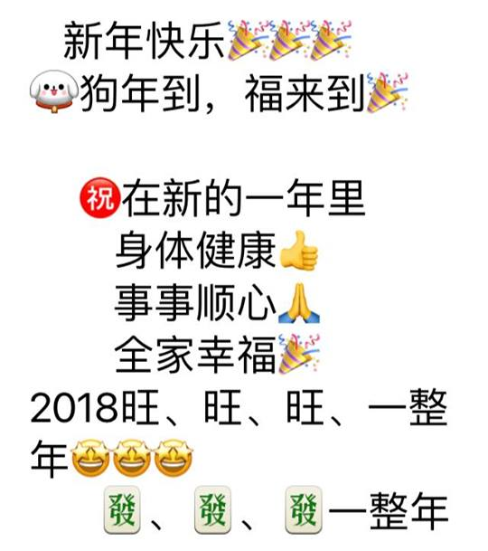 | 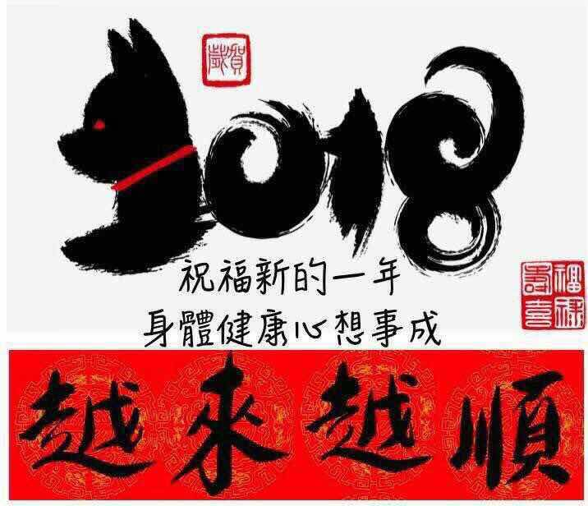
III. Vocabulary Table
中文 (Chinese) | 拼音 (Pinyin) | 英文 (English)
中国 | zhōng guó | China
新年 | xīn nián | New Year
快乐 | kuài lè | Quick + Happiness =>Happy
到 | dào | Arriving
福 | fú | Blessings
来 | lái | Come
祝 | zhù | Wish
的 | de | Of; possessive particle
身体 | shēn tǐ | Body
健康 | jiàn kāng | Health
事 | shì | Thing
顺心 | shun xīn | Smooth + Heart => Satisfied
全家 | quánjiā | The whole family
幸福 | xìngfú | Fortunate blessings
旺 | wàng | Prosperous
發 | fā | Blooming
整 | zhěng | Whole
**Homework: Write at least twice Chinese characters and Pinyin above.
IV. 对话 Dialogue
新年快乐
Xīn nián kuài lè
Happy New Year!

狗年到，福来到
gǒu nián dào, fú lái dào
Dog year approaching, Blessings come.

祝在新的一年里
zhù zài xīn de yī nián lǐ
Wish you in the New Year

身体健康
shēn tǐ jiàn kāng
Having healthy body

事事顺心
shì shì shun xīn
Everything going smoothly

全家幸福
quán jiā xìng fú
Fortunate blessings to your whole family

2018旺、旺、旺、一整年
2018 wàng, wàng, wàng, yī zhěng nián
2018 Prosperious, prosperious, prosperious in a whole year

發、發、發 、一整年
fā, fā, fā， yī zhěng nián
Booming, booming, booming in a whole year

V. Videos
- Video [6:58]: 快閃吧~恭喜發財新年好 Flash mob -- Happy Lunar New Year
- Video [2:14]: 昨夜，西安点亮了半个中国！无数人被美哭 （Terracotta Warriors）
- Video [13:02]: 春 运 Spring Festival Travel Season
- Video [6:04]: The Chinese zodiac, explained | ShaoLan
- Video [4:22]: The myth behind the Chinese zodiac
- Video [2:36]: 特朗普外孙女唱中文歌、背古诗
- Video [1:31]: Most complicated Chinese Character - biáng

