第五课 元宵节 Lesson 5 Lantern Festival
I. Pinyin Chart
b p m f d t n l  g k h j q x  zh ch sh r z c s  i u ϋ a o e ê  ai ei ao ou  an en ang eng er | - Video [3:16]: 聲母韻母歌  - Video [5:41]: The Chinese Phonetic Song 汉语拼音歌

II. Vocabulary Table
How to write Chinese characters? Top to down and left to right
中文 (Chinese) | 拼音 (Pinyin) | 英文 (English)
元宵节 | yuán xiāo jié | Lantern Festival
今天 | jīn tiān | Today
明天 | míng tiān | Tomorrow
号 | hào | Number, Date
阴历 | yīn lì | Lunar Calendar
正月 | zhēng yuè | Sharp+Month=>First Month
会 | huì | Can, be able to
做 | zuò | Do
事 | shì | Thing
吃 | chī | Eat
汤圆 | tang yuán | Rice dumplings
点 | diǎn | Lighten
灯笼 | dēng lóng | Light+Cage=>Latern
**Homework: Write at least twice Chinese characters and Pinyin above.

IV. 对话 Dialogue
A: 今天是几月几号？
Jīn tiān shì jǐ yuè jǐ hào?
What's the date of today?
B: 今天是三月一日。明天是元宵节。明天是阴历的正月十五日。
Jīn tiān shì sān yuè yī rì. Míng tiān shì yuán xiāo jié. Míng tiān shì yīn lì de zhēng yuè shí wǔ rì.
Today is March 1st. Tomorrow is the Lantern Festival. Tomorrow is January 15 in the lunar calendar.
A: 明天你们会做什么事呢？
Míng tiān nǐ men huì zuò shén me shì ne?
What are you going to do tomorrow?
B: 我们会吃汤圆和点灯笼。
Wǒ men huì chī tang yuán hé diǎn dēng lóng.
We'll eat dumplings and play lanterns.
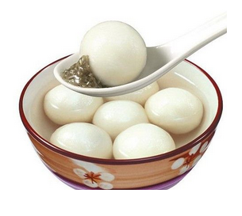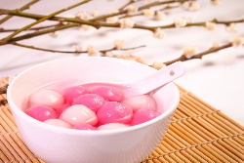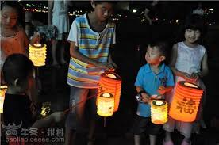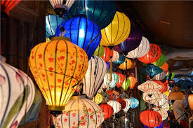

V. Videos
- Video [5:33]: 元宵节 Exploring Chinese Culture - Lantern Festival
- Video [3:32]: The Chinese Lantern Festival
- Video [3:12]: Lantern Festival: What you need to know 元宵节
- Video [6:04]: The Chinese zodiac, explained | ShaoLan
- Video [4:22]: The myth behind the Chinese zodiac
- Video [2:36]: 特朗普外孙女唱中文歌、背古诗

